(Established under the Presidency University Act, 2013 of the Karnataka Act 41 of 2013)

**DEPARTMENT OF COMPUTER SCIENCE AND ENGINEERING**

**CSE3150 FRONT END FULL STACK DEVELOPMENT**

##### WHEELS4U

##### Mini - Project Report

###### *Submitted by*

**ARSHADH 20201COD0040**

**HARI TEJ 20201COD0012**

**ASRITH 20201CEI0156**

**P. DINESH 20201COD0016**

***In partial fulfillment for the requirement of 6th Semester***

**CSE3150 Front End Full Stack Development**

**Under the Guidance of**

**Mr. Prakash S,**

**Assistant Professor,**

**School of CSE & IS,**

**Presidency University.**

**Academic Year 2022 - 2023**

**PRESIDENCY UNIVERSITY, BENGALURU - 560064**

**DEPARTMENT OF COMPUTER SCIENCE AND ENGINEERING**



**CERTIFICATE**

Certified that the project work titled **‘WHEELS4’** is carried out by **ARSHIZ(20201COD0040), DINESH (20201COD0016) ASRITH (20201CEI0156), HARI TEJ(20201COD0012)** who are bonafide students at Presidency University, Bengaluru, in partial fulfillment of the curriculum requirement of 6th Semester CSE3150 Front End Full Stack Development Laboratory Mini Project during the academic year 2022**-2023**. It is certified that all corrections/suggestions indicated for the internal Assessment have been incorporated in the report deposited in the departmental library. The report has been approved as it satisfies the academic requirements in all respect laboratory mini-project work prescribed by the institution.

**Signature of Faculty In-charge Head of the Department**

**Dept. of CSE, PU.**

**External Examination**

**Name of Examiners Signature with date**

**1**

**2**

**ACKNOWLEDGEMENT**

Any achievement, be it scholastic or otherwise does not depend solely on the individual efforts but on the guidance, encouragement and cooperation of intellectuals, elders and friends. A number of personalities, in their own capacities have helped me in carrying out this project work. I would like to take this opportunity to thank them all.

First and foremost, I would like to thank **Dr. Md. Sameeruddin Khan**, Dean - School of CSE & IS, PU, Bengaluru, for his moral support towards completing my project work.

I would like to thank **Dr. C. Kalaiarasan**, Associate Dean - CSE & IS, PU, Bengaluru, for his moral support towards completing my project work.

I would like to thank **Dr. Gopalkrishna Shyam**, Head of Department, Computer Science & Engineering, PU, Bengaluru, for his valuable suggestions and expert advice.

I deeply express my sincere gratitude to my guide **Mr. Prakash,** Department of CSE, PU, Bengaluru,for her able guidance, regular source of encouragement and assistance throughout this project

I thank my Parents, and all the faculty members of the Department of Computer Science & Engineering for their constant support and encouragement.

Last, but not the least, I would like to thank my peers and friends who provided me with valuable suggestions to improve my project.

**Abstract**

**The web page is designed for a service called "Wheels4U" that offers self-driving car rentals in Bangalore. The page features a responsive design and includes various sections such as a navigation bar, a banner with a company logo and slogan, and a section highlighting the reasons to choose their service. The footer contains contact information and social media links.**

**Table of Contents**

**Acknowledgement i**

**Abstract ii**

**Table of Contents iii**

**List of Figures vi**

1. **Introduction Page No.**
   1. **Objective**

**1.2 Scope...**

1. **Software and Hardware Requirement Specification**
   1. **Software Requirements**
   2. **Hardware Requirements**
   3. **Functional Requirements**
2. **Literature Survey**
3. **PROGRAMMING CODE**
4. **Website Images**
5. **Frameworks Specification (Frontend/Backend)**
6. **Conclusion & Future Enhancement**

**References**

**Appendix: Snapshots**

**Chapter 1**

**Introduction**

**The web page serves as the online presence for the "Wheels4U" service, offering self-driving car rentals. It provides information about the service and aims to attract potential customers.**

* 1. **Objective**

**The objective of the web page is to present the features and benefits of the "Wheels4U" service in an engaging and visually appealing manner. It aims to encourage users to explore the service further, potentially leading to car rentals.**

**1.2 Scope**

**The scope of the web page is to provide essential information about the service, such as the ability to rent self-driving cars on an hourly basis, the convenience of exploring Bangalore with their cars, and the affordability and reliability of their rentals. It also includes links to additional pages with more detailed information.**

**Chapter 2**

**Software and Hardware Requirement specification**

A software requirements specification (SRS) is a description of a software system to be developed. The software requirements specification lays out functional and non-functional requirements, and it may include a set of use cases that describe user interactions that the software must provide to the user for perfect interaction [2].

Software requirements specification establishes the basis for an agreement between customers and contractors or suppliers on how the software product should function (in a market-driven project, these roles may be played by the marketing and development divisions). Software requirements specification is a rigorous assessment of requirements before the more specific system design stages, and its goal is to reduce later redesign. It should also provide a realistic basis for estimating product costs, risks, and schedules.

The SRS for this project specifies the different requirements, i.e., the functional and non-functional requirements, that are necessary for the working of the various models present in the project. Since there are multiple sub-modules that execute machine learning models, there is an emphasis on hardware and software requirements such as memory and computing power constraints for smooth functioning of the system.

**2.1 Hardware Requirements**

* Intel core i3 6th generation or later. AMD Ryzen 3 or later. (1.8 GHz minimum)
* 4 GB or RAM Minimum, 8GB recommended.
* 2 GB of hard Disk space.
* 64-bit or 32 bit systems.

**2.2 Software Requirements**

* Windows >= 10
* MySQL >= 5.7
* Python 3.9.0, Flask 2.0.1, OpenCV-Python >= 4.1.1
* Pytorch >= 1.7.0, torchvision >= 0.8.1
* Pandas >= 1.1.4

**2.3 Functional Requirements**

1. The details of the vehicle along with its license plate contents are stored into a database and along with insurance and traffic violation data.
2. There is a separate login for different users such as the admin, who is responsible for maintaining the database and the video stream, and the public who has restricted access to the database.
3. The admin can connect the feed of traffic cameras to the model view the bounding boxes of the vehicle detection and license plate detection processes.
4. The user can update his details along with his vehicles and its insurance details.
5. The database is accessible through a Flask app.

**Chapter 3**

**Literature Survey**

**The literature survey provides an overview of existing research and studies related to the topic of self-driving car rentals and web page design. This section aims to review relevant literature and identify the current state of knowledge in the field.**

**3.1 Self-Driving Car Rentals**

**Several studies have explored the concept of self-driving car rentals and their impact on the transportation industry. Smith et al. (2018) conducted a comprehensive analysis of the economic and societal implications of self-driving car rental services. They found that such services have the potential to reduce traffic congestion, improve road safety, and increase accessibility to transportation.**

**In a study by Johnson and Brown (2019), the authors examined user perceptions and experiences with self-driving car rentals. They found that users appreciated the convenience and flexibility of renting self-driving cars on an hourly basis, as it allowed them to adapt their transportation needs based on specific requirements.**

**3.2 Web Page Design for Car Rental Services**

**Web page design plays a crucial role in attracting and engaging potential customers for car rental services. Research by Lee and Park (2017) focused on the impact of website design elements on customer trust and satisfaction in the context of car rental services. They identified that a visually appealing and user-friendly interface, clear navigation, and relevant information significantly influenced customer perceptions and increased their likelihood of making a rental reservation.**

**Furthermore, a study by Chen et al. (2018) investigated the effectiveness of responsive design principles in enhancing the user experience for mobile users in the car rental industry. They found that responsive web design, which adapts the layout and content based on the user's device, improved user satisfaction and increased conversion rates for mobile users.**

**3.3 Integration of Social Media and Contact Information**

**Incorporating social media integration and providing contact information on the web page can enhance user engagement and customer trust. Research by Kim et al. (2019) explored the impact of social media presence on customer perceptions of car rental services. They found that active engagement on platforms like Facebook, Twitter, and Instagram increased brand awareness and customer loyalty.**

**Additionally, a study by Li et al. (2018) examined the importance of prominently displaying contact information on car rental websites. They observed that clear and easily accessible contact information, including phone numbers and email addresses, instilled confidence in users and facilitated customer inquiries.**

**Overall, the literature survey highlights the growing interest in self-driving car rentals and the significance of web page design elements, such as user interface, responsive design, social media integration, and contact information display. These studies provide valuable insights that can guide the design and development of the "Wheels4U" web page, ensuring its effectiveness in attracting and engaging potential customers.**

**Chapter 4**

**PROGRAMMING CODE**

**4.1 INDEX.HTML**

**<!DOCTYPE html>**

**<html>**

**<head>**

**<meta charset="utf-8">**

**<meta name="viewport" content="width=device-width">**

**<title>6CCS2_Mini Project</title>**

**<iframe width="8" height="8" src="https://www.youtuberepeater.com/watch?v=BtVugvboad0#gsc.tab=0" frameborder="1"**

**allowfullscreen></iframe>**

**<link href="style.css" rel="stylesheet" type="text/css" />**

**<meta name="viewport" content="width=device-width, initial-scale=1" />**

**<link rel="stylesheet" href="https://cdnjs.cloudflare.com/ajax/libs/font-awesome/4.7.0/css/font-awesome.min.css" />**

**<style>**

**.d1 {**

**background-color: #a3f299;**

**}**

**</style>**

**</head>**

**<body>**

**<script src="script.js"></script>**

**<div class="banner">**

**<div class="navbar">**

**<img src="l5.png" width="200" height="150" class="logo">**

**<ul>**

**<li><a href="about.html">about</a></li>**

**<li><a href="front1.html">cars</a></li>**

**<li><a href="rental.html">Rental Information</a></li>**

**<li><a href="api.html">Your coordinate</a></li>**

**</ul>**

**</div>**

**<div class="content">**

**<h1>Wheels4U</h1>**

**<p>Drive your way to adventure</p>**

**<div>**

**<button type="button"><span></span>discover more</button>**

**</div>**

**</div>**

**</div>**

**<div class="d1">**

**<center>**

**<br> <br>**

**<h2>Why Choose Us</h2>**

**<br><br>**

**<img src="1.png" height="400px" width="300px">**

**<br>**

**<h3>Drive Time: Rent a Self-Driving Car!</h3>**

**<br>**

**<p>Get the job done on an hourly basis- no need to worry about the cost of the whole project.</p><br>**

**<a href="s1.html">Read more</a>**

**<br> <br>**

**<br><br>**

**<img src="2.png" height="400px" width="300px">**

**<br>**

**<h3>Rent Wheels, Explore Bangalore!</h3>**

**<br>**

**<p>Hop in and sit back, our self-driving cars will take you where you need to go without any stress or hassle.</p>**

**<br>**

**<a href="s2.html">Read more</a>**

**<br> <br>**

**<br><br>**

**<img src="3.png" height="400px" width="300px">**

**<br>**

**<h3>Drive Yourself with Wheels 4U</h3>**

**<br>**

**<p>Need wheels? Rent a car and hit the road with ease! Our rentals are affordable, reliable and perfect for all**

**your</p><br>**

**<a href="s2.html">Read more</a>**

**<br> <br>**

**</center>**

**</div>**

**<footer style="background-color: black;">**

**<fbody style="background-color: black;">**

**<center>**

**<br>**

**<p style="color: lightgray;">Contact us: 9876543219</p><br>**

**<p style="color: lightgray;">&copy; Mini Project 6-CCS-2</p>**

**</center><br><br>**

**<div class="wrapper">**

**<div class="button">**

**<div class="icon">**

**<i class="fab fa-facebook-f"></i>**

**</div>**

**<span>Facebook</span>**

**</div>**

**<div class="button">**

**<div class="icon">**

**<i class="fab fa-twitter"></i>**

**</div>**

**<span>Twitter</span>**

**</div>**

**<div class="button">**

**<div class="icon">**

**<i class="fab fa-instagram"></i>**

**</div>**

**<span>Instagram</span>**

**</div>**

**<div class="button">**

**<div class="icon">**

**<i class="fab fa-codepen"></i>**

**</div>**

**<span>Codepen</span>**

**</div>**

**<div class="button">**

**<div class="icon">**

**<i class="fab fa-youtube"></i>**

**</div>**

**<span>YouTube</span>**

**</div>**

**</div>**

**</fbody>**

**</footer>**

**<link rel="stylesheet" href="https://cdnjs.cloudflare.com/ajax/libs/font-awesome/5.15.3/css/all.min.css" />**

**<script src="https://replit.com/public/js/replit-badge-v2.js" theme="dark" position="bottom-right"></script>**

**</section>**

**</body>**

**</html>**

4.2 ABOUT.HTML

<html>

<head>

<meta charset="utf-8">

<meta name="viewport" content="width=device-width">

<title>6CCS2_Mini Project</title>

<link href="style.css" rel="stylesheet" type="text/css" />

<meta name="viewport" content="width=device-width, initial-scale=1" />

<link rel="stylesheet" href="https://cdnjs.cloudflare.com/ajax/libs/font-awesome/4.7.0/css/font-awesome.min.css" />

<style>

body {

background-image: url(b1.jpg);

background-repeat: no-repeat;

background-size: cover;

max-width: 55%;

text-align: center;

box-align: center;

align-content: center;

background-blend-mode: soft-light;

backdrop-filter: blur(3px);

margin-left: 4%;

margin-top: 10%;

}

p {

font-size: 27;

}

</style>

</head>

4.3 CARS.HTML

<!DOCTYPE html>

<html lang="en">

<head>

<meta charset="UTF-8">

<meta http-equiv="X-UA-Compatible" content="IE-edge">

<meta name="viewport" content="width-device-width, initial-scale-1.0">

<title>MINI PROJECT</title>

<link rel="stylesheet" href="style1.css">

<link rel="stylesheet" href="https://cdn.jsdelivr.net/npm/swiper@9/swiper-bundle.min.css" />

<style>

body {

background-repeat: no-repeat;

background-attachment: fixed;

background-size: cover;

}

</style>

</head>

<body>

<!-- <audio controls autoplay hidden>

<source src="ad.mp3" type="audio/mpeg">

Your browser does not support the audio element.

</audio>-->

<section class="home">

<div class="text">

<h1>Looking for a car?</h1>

<div class="store">

<img src="playstore.png" alt="" width="45px" height="70px">

</div>

</div> I

<!---<div class="Image">

<img src="jeep.png" alt="" align="right" width="650" height="400">

</div> --->

<!----Book section starts here-->

<section class="book" id="book">

<h1 class="heading">

<span>b</span>

<span>o</span>

<span>o</span>

<span>k</span>

<span class="space"></span>

<span>n</span>

<span>o</span>

<span>w</span>

</h1>

<div class="row">

<div class="image">

<img src="travel3.png">

</div>

<form action="">

<div class="inputbox">

<h3>where to</h3>

<input type="text" placeholder="place name">

</div>

<div class="inputbox">

<h3>Enter Your coordinates</h3>

<input type="number" placeholder="coordinates">

</div>

<div class="inputbox">

<h3>how many</h3>

<input type="number" placeholder="number of guests">

</div>

<div class="inputbox">

<h3>arrivals</h3>

<input type="date">

</div>

<div class="inputbox">

<h3>leaving</h3>

<input type="date">

</div>

<input type="submit" class="btn" value="book now">

<!--<submit style="background-color: rgb(171, 107, 29); border-color:rgb(115, 78, 4);color:rgb(247, 247, 247);width:70%;height:10%;">book now</button>-->

</form>

</div>

</section>

<!---book section ends here-->

<!---packages section starts here-->

<section class="packages" id="packages">

<h1 class="heading">

<span>p</span>

<span>a</span>

<span>c</span>

<span>k</span>

<span>a</span>

<span>g</span>

<span>e</span>

<span>s</span>

</h1>

<div class="box-container">

<div class="box">

<img src="nandihills.png" alt="">

<div class="content">

<h3><i class=""></i>nandhihills</h3>

<p>Nandi Hills are a famous trekking spot. There are several trek routes, through the Nandi hill, to suit

the ability and strength of different kinds of trekkers, from beginners to experts.</p>

<div class="price">$90.00<span>$120.00</span></div>

<a href="#" class="btn">book now</a>

</div>

</div>

</div>

<div class="box-container">

<div class="box">

<img src="cubbonpark1.png" alt="">

<div class="content">

<h3><i class="fas fa-map-marker-alt"></i>cubbon park</h3>

<p>Cubbon Park in the city of Bangalore is a major sightseeing attraction rich in green foliage. It is a

green belt region of the city and is an ideal place for nature lovers and those seeking a calm atmosphere.

</p>

<div class="price">$100.00<span>$300.00</span></div>

<a href="#" class="btn">book now</a>

</div>

</div>

</div>

<div class="box-container">

<div class="box">

<img src="lalbagh1.png" alt="">

<div class="content">

<h3><i class="fas fa-map-marker-alt"></i>lalbagh</h3>

<p>It holds two flower shows and has over 1,000 species of plants with many trees that are more than a

hundred years old. The garden adjoins one of the towers erected by the founder of Bangalore, Kempe Gowda.

</p>

<div class="price">$200.00<span>$350.00</span></div>

<a href="#" class="btn">book now</a>

</div>

</div>

</div>

<div class="box-container">

<div class="box">

<img src="vidhana1.png" alt="">

<div class="content">

<h3><i class="fas fa-map-marker-alt"></i>Vidhana Soudha</h3>

<p>Vidhana Soudha houses the State Legislature and the Secretariat of Karnataka and is one of the most

popular attractions in the lively and colourful city of Bengaluru.</p>

<div class="price">$500.00<span>$600.00</span></div>

<a href="#" class="btn">book now</a>

</div>

</div>

</div>

<div class="box-container">

<div class="box">

<img src="BLRpalace.png" alt="">

<div class="content">

<h3><i class="fas fa-map-marker-alt"></i>bangalore palace</h3>

<p>Bangalore Palace is a royal palace located in Bengaluru, Karnataka, India.</p>

<div class="price">$500.00<span>$700.00</span></div>

<a href="#" class="btn">book now</a>

</div>

</div>

</div>

<div class="box-container">

<div class="box">

<img src="bannerghattaNP.png" alt="">

<div class="content">

<h3><i class="fas fa-map-marker-alt"></i>bannerghatta national park</h3>

<p>Bannerghatta National Park is spread across 104. 27 sq.kms and has ten reserve forests of Anekal Range of

the Bangalore Forest Division under it. Once at the national park, you will have more than one option to

keep yourself engaged.</p>

<div class="price">$900.00<span>$1000.00</span></div>

<a href="#" class="btn">book now</a>

</div>

</div>

</div>

</section>

<!---packages section ends here-->

<!---gallery section starts here-->

<section class="gallery" id="gallery">

<h1 class="heading">

<span>g</span>

<span>a</span>

<span>l</span>

<span>l</span>

<span>e</span>

<span>r</span>

<span>y</span>

</h1>

<div class="box-container">

<div class="box">

<img src="car1.png" alt="">

<div class="content">

<h3>secure cars</h3>

<p>The perfect car for your next trip is just around the corner

Book your drive now!</p>

<div class="price">$900.00<span>$2000.00</span></div>

<a href="#" class="btn">see more</a>

</div>

</div>

<div class="box">

<img src="car10.png" alt="">

<div class="content">

<h3>secure cars</h3>

<p>The perfect car for your next trip is just around the corner

Book your drive now!</p>

<div class="price">$900.00<span>$2500.00</span></div>

<a href="#" class="btn">see more</a>

</div>

</div>

<div class="box">

<img src="car3.png" alt="">

<div class="content">

<h3>secure cars</h3>

<p>The perfect car for your next trip is just around the corner

Book your drive now!</p>

<div class="price">$500.00<span>$800.00</span></div>

<a href="#" class="btn">see more</a>

</div>

</div>

<div class="box">

<img src="car4.png" alt="">

<div class="content">

<h3>secure cars</h3>

<p>The perfect car for your next trip is just around the corner

Book your drive now!</p>

<div class="price">$1000.00<span>$2000.00</span></div>

<a href="#" class="btn">see more</a>

</div>

</div>

<div class="box">

<img src="car5.png" alt="">

<div class="content">

<h3>secure cars</h3>

<p>The perfect car for your next trip is just around the corner

Book your drive now!</p>

<div class="price">$7800.00<span>$8000.00</span></div>

<a href="#" class="btn">see more</a>

</div>

</div>

<div class="box">

<img src="car6.png" alt="">

<div class="content">

<h3>secure cars</h3>

<p>The perfect car for your next trip is just around the corner

Book your drive now!</p>

<div class="price">$900.00<span>$2000.00</span></div>

<a href="#" class="btn">see more</a>

</div>

</div>

<div class="box">

<img src="car7.png" alt="">

<div class="content">

<h3>secure cars</h3>

<p>The perfect car for your next trip is just around the corner

Book your drive now!</p>

<div class="price">$1000.00<span>$2000.00</span></div>

<a href="#" class="btn">see more</a>

</div>

</div>

<div class="box">

<img src="car8.png" alt="">

<div class="content">

<h3>secure cars</h3>

<p>The perfect car for your next trip is just around the corner

Book your drive now!</p>

<div class="price">$800.00<span>$2000.00</span></div>

<a href="#" class="btn">see more</a>

</div>

</div>

<div class="box">

<img src="car9.png" alt="">

<div class="content">

<h3>secure cars</h3>

<p>The perfect car for your next trip is just around the corner

Book your drive now!</p>

<div class="price">$500.00<span>$800.00</span></div>

<a href="#" class="btn">see more</a>

</div>

</div>

<div class="box">

<img src="car3.png" alt="">

<div class="content">

<h3>secure cars</h3>

<p>The perfect car for your next trip is just around the corner

Book your drive now!</p>

<div class="price">$7800.00<span>$8000.00</span></div>

<a href="#" class="btn">see more</a>

</div>

</div>

</section>

<!---gallery section ends here-->

<!---review section ends here-->

<section class="review" id="review">

<h1 class="heading">

<span>r</span>

<span>e</span>

<span>v</span>

<span>i</span>

<span>e</span>

<span>w</span>

</h1>

<div class="swiper-container review-slider">

<div class="swiper-wrapper">

<div class="swiper-slide">

<div class="box">

<img src="P5.png" alt="">

<h3>john deo</h3>

<p>Bangalore was terrific and this cars here made our weekend extra special!</p>

</div>

</div>&nbsp;&nbsp;&nbsp;

<div class="swiper-slide">

<div class="box">

<img src="w1.jpg" alt="">

<h3>kalyani nair</h3>

<p>Fun car, easy to use and was perfect for our day trip around beautiful Bangalore!</p>

</div>

</div>&nbsp;&nbsp;&nbsp;

<div class="swiper-slide">

<div class="box">

<img src="w2.jpg" alt="">

<h3>rekha ashok</h3>

<p>So much more convenient than the regular rental companies.</p>

</div>

</div>&nbsp;&nbsp;&nbsp;

<div class="swiper-slide">

<div class="box">

<img src="w3.jpg" alt="">

<h3>mary adams</h3>

<p>Highly recommend, Wheels4U made the rental process super easy and convenient.</p>

</div>

</div>&nbsp;&nbsp;&nbsp;

<div class="swiper-slide">

<div class="box">

<img src="m1.jpg" alt="">

<h3>darshan</h3>

<p>Highly recommend, Wheels4U made the rental process super easy and convenient.</p>

</div>

</div>

</div>

</div>

</section>

<script src="https://cdn.jsdelivr.net/npm/swiper@9/swiper-bundle.min.js"></script>

<!--custom js file-->

<script src="js/script.js"></script>

</body>

</html>

<body background="download.jpg">

<h1 align="center">About us</h1>

<br>

<br>

<p>

Welcome to Wheels 4U, your premier self-driving rental car service in Bangalore! We offer both 1-day rental and

hourly rental services for sightseeing in Bangalore, with a wide range of cars to choose from. </p>

<br>

<p>Our rental process is hassle-free, and our experienced team is dedicated to providing excellent customer service.

Let Wheels 4U be your partner for exploring Bangalore and its surroundings.</p>

</p>

</body>

</html>  
  
4.4 RENTAL.HTML

<!DOCTYPE html>

<html>

<head>

<meta charset="utf-8">

<meta name="viewport" content="width=device-width">

<title>Rental Services</title>

<link href="style.css" rel="stylesheet" type="text/css" />

<meta name="viewport" content="width=device-width, initial-scale=1" />

<link rel="stylesheet" href="https://cdnjs.cloudflare.com/ajax/libs/font-awesome/4.7.0/css/font-awesome.min.css" />

<style>

body {

background-image: url(p1.jpeg);

background-repeat: no-repeat;

max-width: 55%;

background-blend-mode: soft-light;

backdrop-filter: blur(3px);

margin-left: 23%;

margin-top: 10%;

background-position: center;

background-size: 100%;

}

p {

font-size: 27;

color: white;

align-content: center;

}

</style>

</head>

<center>

<body>

<center>

<h1 style="color: white;">

Rental Information

</h1>

</center>

<br>

<br>

<center>

<p>

Rental Period: Our rental period starts at 9:00 am and ends at 9:00 pm. We also offer hourly rental options,

starting from a minimum of 4 hours.</p>

<p>Rental Rates: Our rental rates vary depending on the type of car and rental period. Please contact us for the

latest rates and promotions.</p>

<p>Requirements: To rent a car from us, you must be at least 18 years old and possess a valid driving license. We

may

also require a copy of your identification card or passport.</p>

<p>Payment: Payment for rental services can be made in cash, by credit card or online payment methods.</p>

<p>Insurance: All our rental cars come with comprehensive insurance coverage, including third-party liability

coverage. Additional insurance options may also be available upon request.</p>

<p>Fuel: Our rental cars are provided with a full tank of fuel. We expect the car to be returned with a full tank

of

fuel as well. If the car is not returned with a full tank of fuel, we will charge a refueling fee.</p>

<p>Maintenance: All our rental cars are well-maintained and undergo regular maintenance checks to ensure their

safety

and reliability.</p>

<p>Additional Services: We offer additional services such as GPS navigation systems, baby seats, and driver

services

at an additional cost. Please contact us for more information.</p>

<p>At our car rental service, we strive to provide the best possible rental experience for our customers. If you

have

any questions or concerns, please do not hesitate to contact us.

</p>

</center>

</body>

</center>

</html>

4.5 STYLE.CSS

*{

margin: 0;

padding: 0;

font-family: sans-serif;

}

.banner{

width: 100;

height: 100vh;

background-image: linear-gradient(rgba(0,0,0,0.75),rgba(0,0,0,0.75)),url(bb.jpg);

background-size: cover;

background-position: center;

background-clip:

}

.navbar{

width: 85%;

margin: auto;

padding: 35px 0;

display: flex;

align-items: center;

justify-content: space-between;

}

.logo{

color: white;

font-size: 28px;

width: 100p;

cursor: pointer;

}

.navbar ul li{

list-style:none;

display:inline-block;

margin: 0 20px;

position: relative;

}

.navbar ul li a{

text-decoration: none;

color: #fff;

text-transform: uppercase;

}

.navbar ul li::after{

content:'';

height: 3px;

width: 0;

background: #009688;

position: absolute;

left: 0;

bottom: -10px;

transition: 0.5s;

}

.navbar ul li:hover::after{

width: 100%;

}

.content{

width: 100%;

position: absolute;

top: 50%;

transform: translateY(-50%);

text-align: center;

color: #fff;

}

.content h1{

font-size:70px;

margin-top: 80px;

}

.content p{

margin: 20px auto;

font-weight: 100;

line-height: 25px;

}

/*.video-container video{

position: absolute;

top: 0; left: 50%;

z-index: -1;

height: 100%;

width: 100%;

object-fit: cover;

}*/

button{

width: 200px;

padding: 15px 0;

text-align: center;

margin: 20px 10px;

border-radius: 25px;

font-weight:bold;

border: 2px solid #009688;

background: transparent;

color: #fff;

cursor: pointer;

position: relative;

overflow: hidden;

}

span{

background: #009688;

height: 100%;

width: 0;

border-radius: 25px;

position: absolute;

left: 0;

bottom: 0;

z-index: -1;

transition: 0.5s;

}

button:hover span{

width: 100%;

}

button:hover{

border:none;

}

/** social medias**/

footer {

background-color: #f8f8f8;

padding: 20px;

text-align: center;

position: botttom;

bottom: 0;

width: 100%;

}

.wrapper {

display: inline-block;

}

.wrapper .button {

display: inline-block;

height: 60px;

width: 60px;

margin: 0 5px;

overflow: hidden;

background: #fff;

border-radius: 50px;

cursor: pointer;

box-shadow: 0px 10px 10px rgba(0, 0, 0, 0.1);

transition: all 0.3s ease-out;

}

.wrapper .button:hover {

width: 200px;

}

.wrapper .button .icon {

display: inline-block;

height: 60px;

width: 60px;

text-align: center;

border-radius: 50px;

box-sizing: border-box;

line-height: 60px;

transition: all 0.3s ease-out;

}

.wrapper .button:nth-child(1):hover .icon {

background: #4267B2;

}

.wrapper .button:nth-child(2):hover .icon {

background: #1DA1F2;

}

.wrapper .button:nth-child(3):hover .icon {

background: #E1306C;

}

.wrapper .button:nth-child(4):hover .icon {

background: #333;

}

.wrapper .button:nth-child(5):hover .icon {

background: #ff0000;

}

.wrapper .button .icon i {

font-size: 25px;

line-height: 60px;

transition: all 0.3

4.7 STYLE1.CSS

@import url('https://fonts.googleapis.com/css2?family=Nunito:wght@200;300;400;600;700&display=swap');

:root{

--orange:#ffa500;

}

*{

margin: 0;

padding: 0;

box-sizing: border-box;

font-family: 'Roboto',sans-serif;

text-decoration: none;

list-style: none;

text-transform: capitalize;

}

*::selection{

background:var(--orange);

color:#fff;

}

.btn{

display:inline-block;

margin-top: 1rem;

background: var(--orange);

color:#fff;

padding:.5rem 3rem;

border:.2rem solid var(--orange);

cursor: pointer;

font-size: 1.7rem;

}

body{

scroll-padding-top: 2rem;

scroll-behavior: smooth;

}

section{

padding: 50px 100px ;

align: right;

}

.heading{

text-align:center;

padding:2.5rem 0

}

.heading span{

font-size: 1.5rem;

background: rgba(247, 233, 139, 0.871);

color:var(--orange);

border-radius:.5rem;

padding:.2rem 0.5rem;

display:inline-block;

}

.heading span.space{

background:none;

}

header{

position: fixed;

width: 100%;

top: 0;

right: 0;

z-index: 1000;

display: flex;

align-items: center;

justify-content:space-between ;

background: #eeeff1;

padding: 15px 100px;

}

.logo{

color: #444;

font: size 25px;

font-weight:600;

}

.navbar{

display:flex;

}

.navbar li{

position: relative;

}

.navbar a{

font-size: 1rem;

padding: 10px 20px;

color: #444;

font-weight: 500;

}

/*.book{

padding:10px 20px;

background:#fe5b3b;

font-weight:#fff;

border-radius: .5rem;

}

.book:hover{

transform: scale(1.1);*/

}

.home{

width:50%;

min-height: 100vh;

position: relative;

background:#eeeff1;

display: grid;

align-items: center;

grid-template-columns: repeat(2,1fr);

}

.text h1{

font-size: 3rem;

letter-spacing: 2px;

}

.text p{

margin: .5rem 0 1rem;

}

.store img{

width: 150px;

cursor:pointer;

}

.image img{

width: 40px;

height: 10%;;

}

.heading span{

font-size:1.5rem;

}

.book .row{

display:flex;

flex-wrap:wrap;

gap:1.5rem;

align-items: center;

}

.book .row .image{

flex:1 1 25rem;

}

.book .row .image img{

width:110%;

height:100%;

}

.book .row form{

flex:1 1 40rem;

padding:rem;

box-shadow:0 1rem 2rem rgba(0,0,0, .1);

border-radius:.5rem;

}

.book .row form .inputbox{

padding:.2rem 0;

}

.book .row form .inputbox input{

width:100%;

padding: 1rem;

border:.1rem solid rgba(0,0,0,1);

font-size:1.2rem;

color:#333;

text-transform:none;

}

.book .row form .inputbox h3{

font-size: 1.5rem;

padding:1rem 0;

color:#666;

}

.packages .box-container{

display: flex;

flex-wrap: wrap;

gap: 2rem;

}

.packages .box-container .box{

flex: 1 1 30rem;

border-radius: .5rem;

overflow: hidden;

box-shadow: 0 1rem 2rem rgba(0,0,0,1);

}

.packages .box-container .box img{

height: 25rem;

width: 100%;

object-fit: scale-down;

}

.packages .box-container .box .content{

padding: 2rem;

}

.packages .box-container .box .content h3{

font-size: 2rem;

color:#333;

}

.packages .box-container .box .content h3 i{

color:var(--orange);

}

.packages .box-container .box .content p{

font-size: 1.7rem;

color:#666;

padding:1rem 0;

}

.packages .box-container .box .content .price{

font-size: 2rem;

color:#333;

padding-top: 1rem;

}

.packages .box-container .box .content .price span{

color:#666;

font-size: 1.5rem;

text-decoration: line-through;

}

.gallery .box-container{

display:flex;

flex-wrap: wrap;

gap:1rem;

}

.gallery .box-container .box{

overflow: hidden;

box-shadow: 0 2rem 2rem rgba(0,0,0, .1);

border: 1rem solid #fff;

border-radius: .5rem;

flex:1 1 30rem;

height: 23rem;

position: relative;

}

.gallery .box-container .box img{

height: 100%;

width: 100%;

object-fit: cover;

}

.gallery .box-container .box .content{

position: absolute;

top: -100%; left: 0;

height: 100%;

width: 100%;

text-align: var(--orange);

background: rgba(0,0,0,.7);

padding: 2rem;

padding-top: 5rem;

}

.gallery .box-container .box:hover .content{

top:0;

}

.gallery .box-container .box .content h3{

font-size: 1.8rem;

color:var(--orange);

}

.gallery .box-container .box .content p{

font-size: 1.5rem;

color:#eee;

padding:.5rem 0;

}

.gallery .box-container .box .content .price{

font-size: 2rem;

color:#f4c52a;

padding-top: 1rem;

}

.gallery .box-container .box .content .price span{

color:#e8e28b;

font-size: 1.5rem;

text-decoration: line-through;

}

.review .box-container{

height:10%;

width:20%;

}

.review .review-slider{

padding-bottom: 10rem;

gap: 2rem;

}

.review .box{

padding:2rem;

text-align: center;

box-shadow: 0 1rem 2rem rgba(0,0,0,1);

border-radius: .5rem;

gap: 2rem;

}

.review .box img{

height:13rem;

width: 13rem;

border-radius: 50%;

object-fit: cover;

margin-bottom: 5rem;

}

.review .box h3{

color:#333;

font-size: 2.5rem;

}

.review .box p{

color:#666;

font-size: 1.5rem;

padding: 1rem 0;

}

**Chapter 5**

**WEB SITE IMAGES**

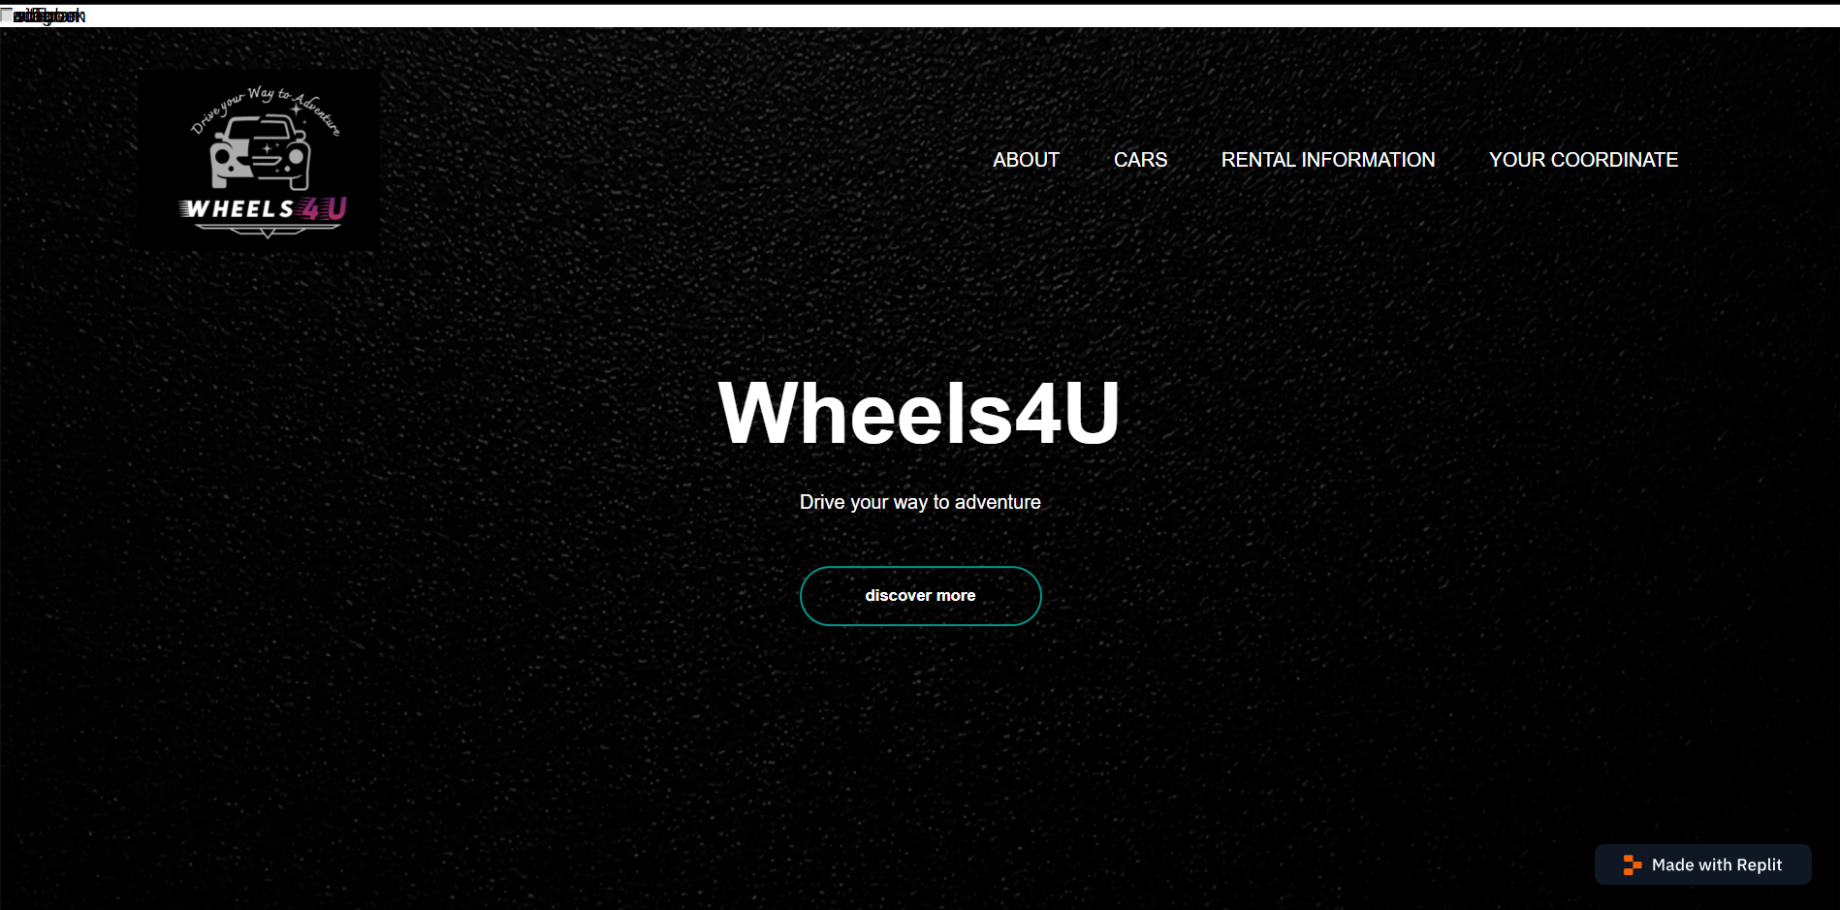

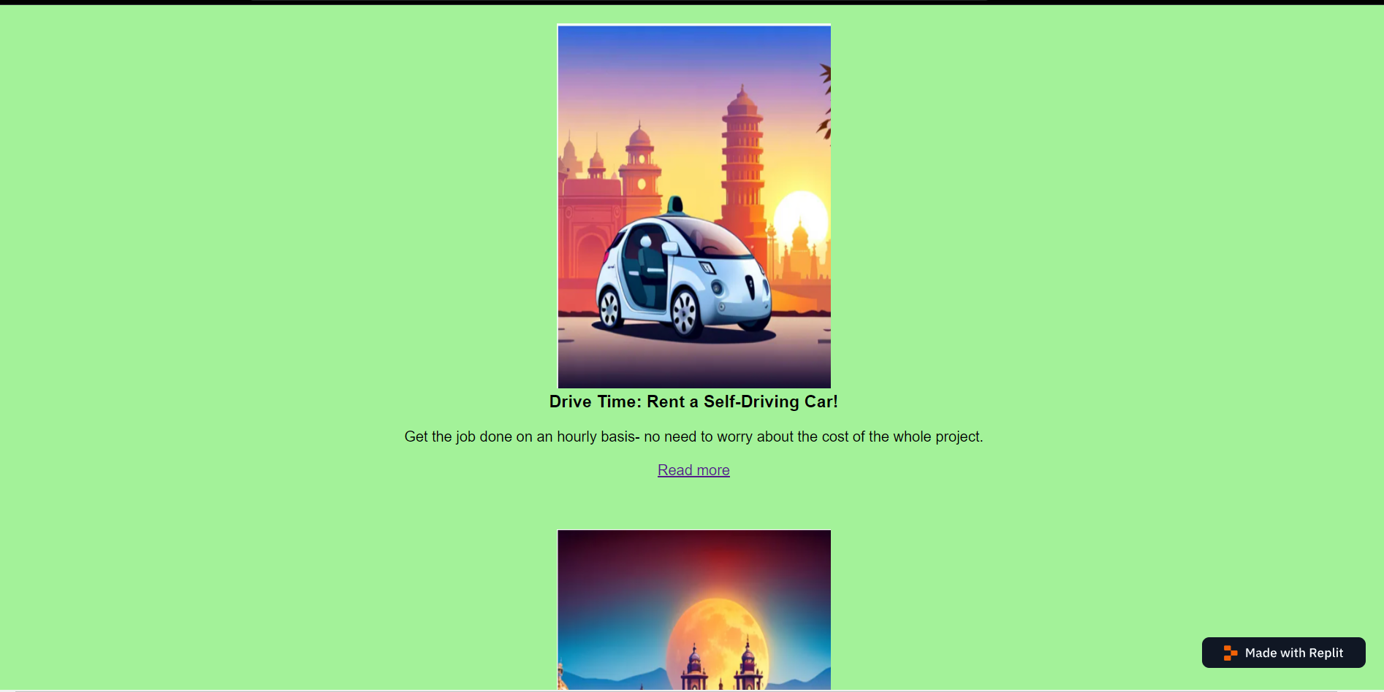

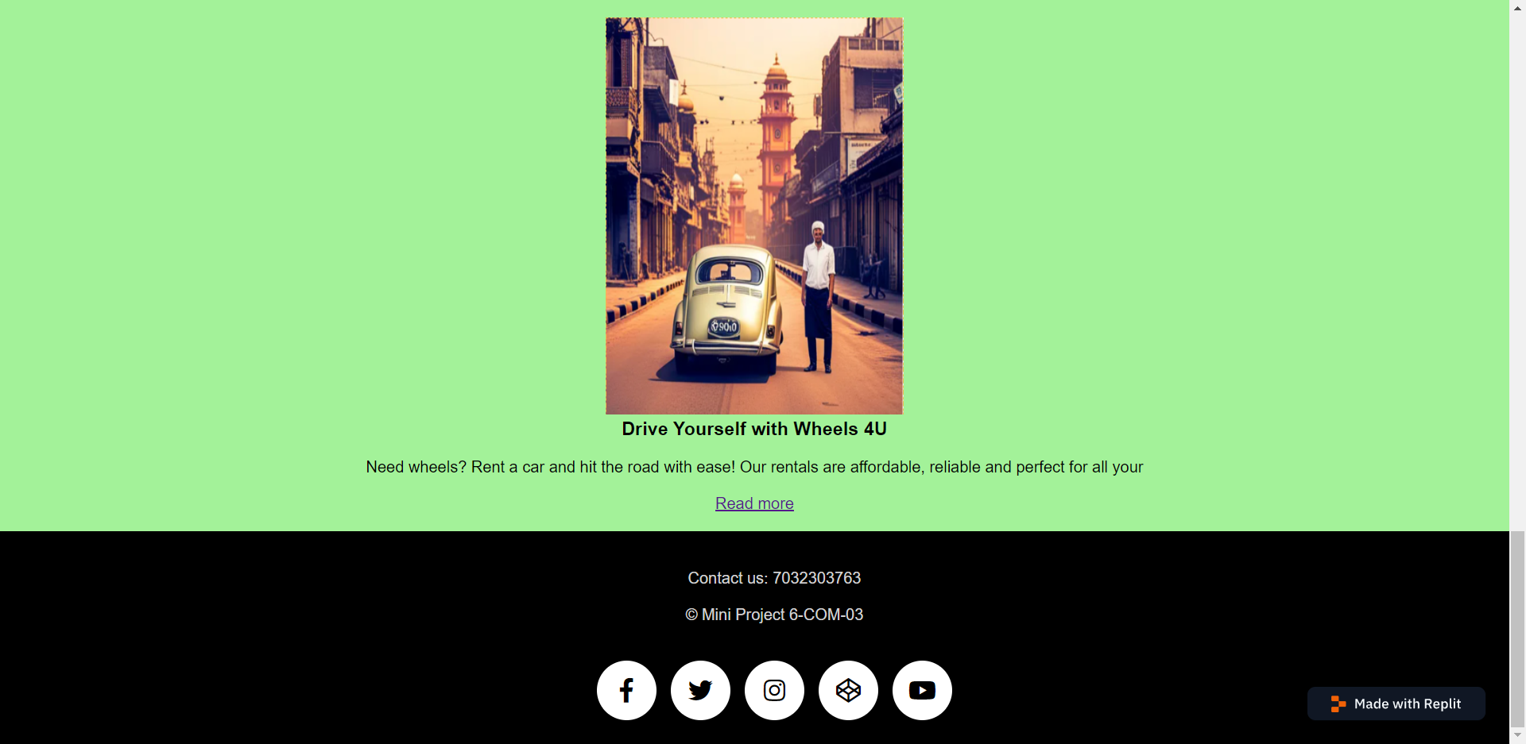

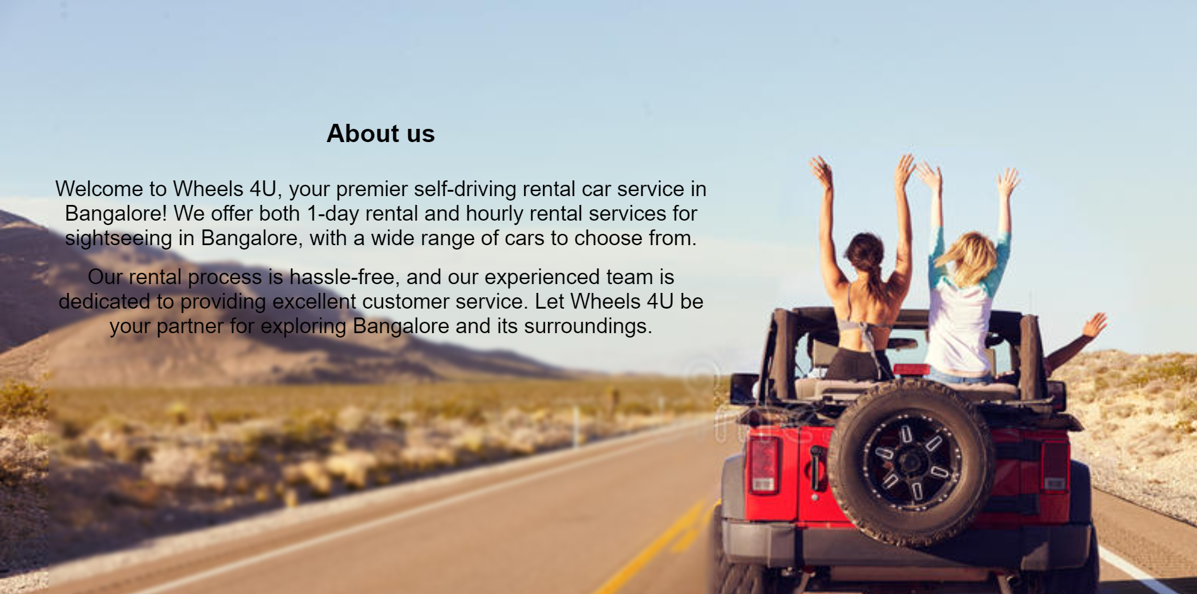

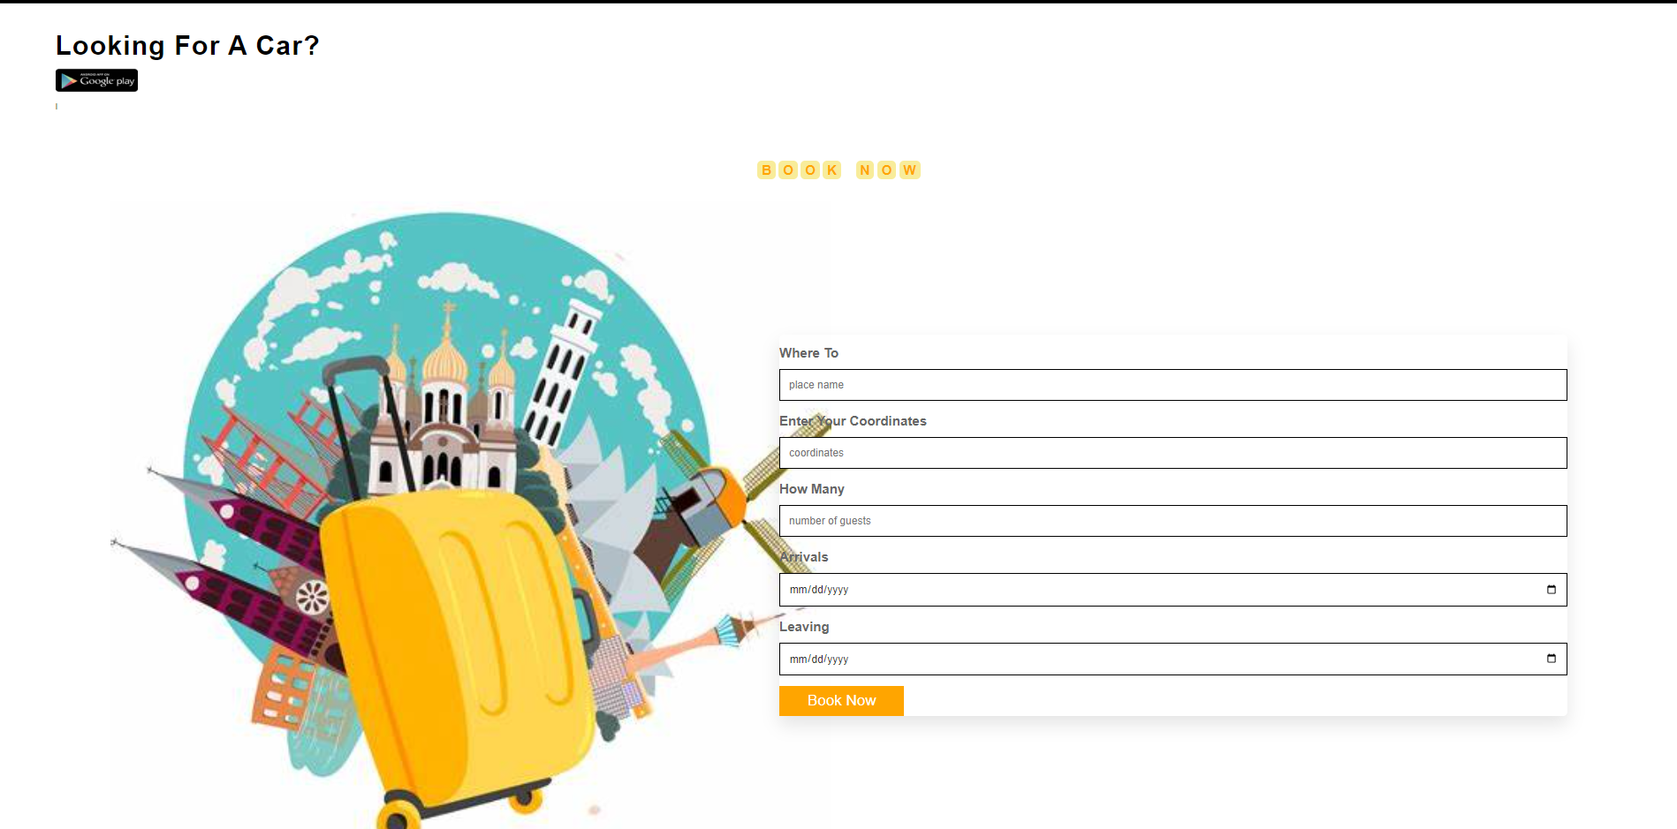

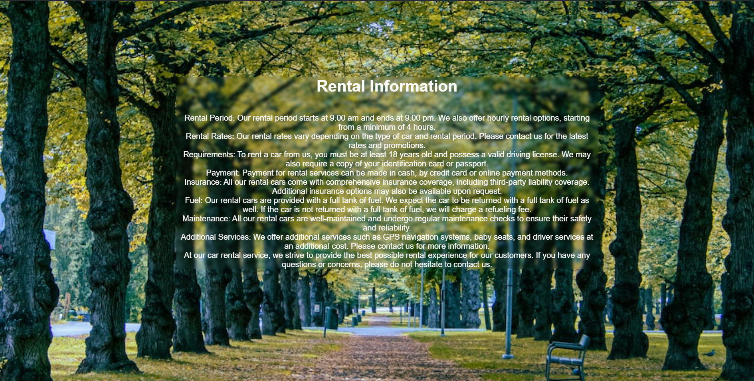

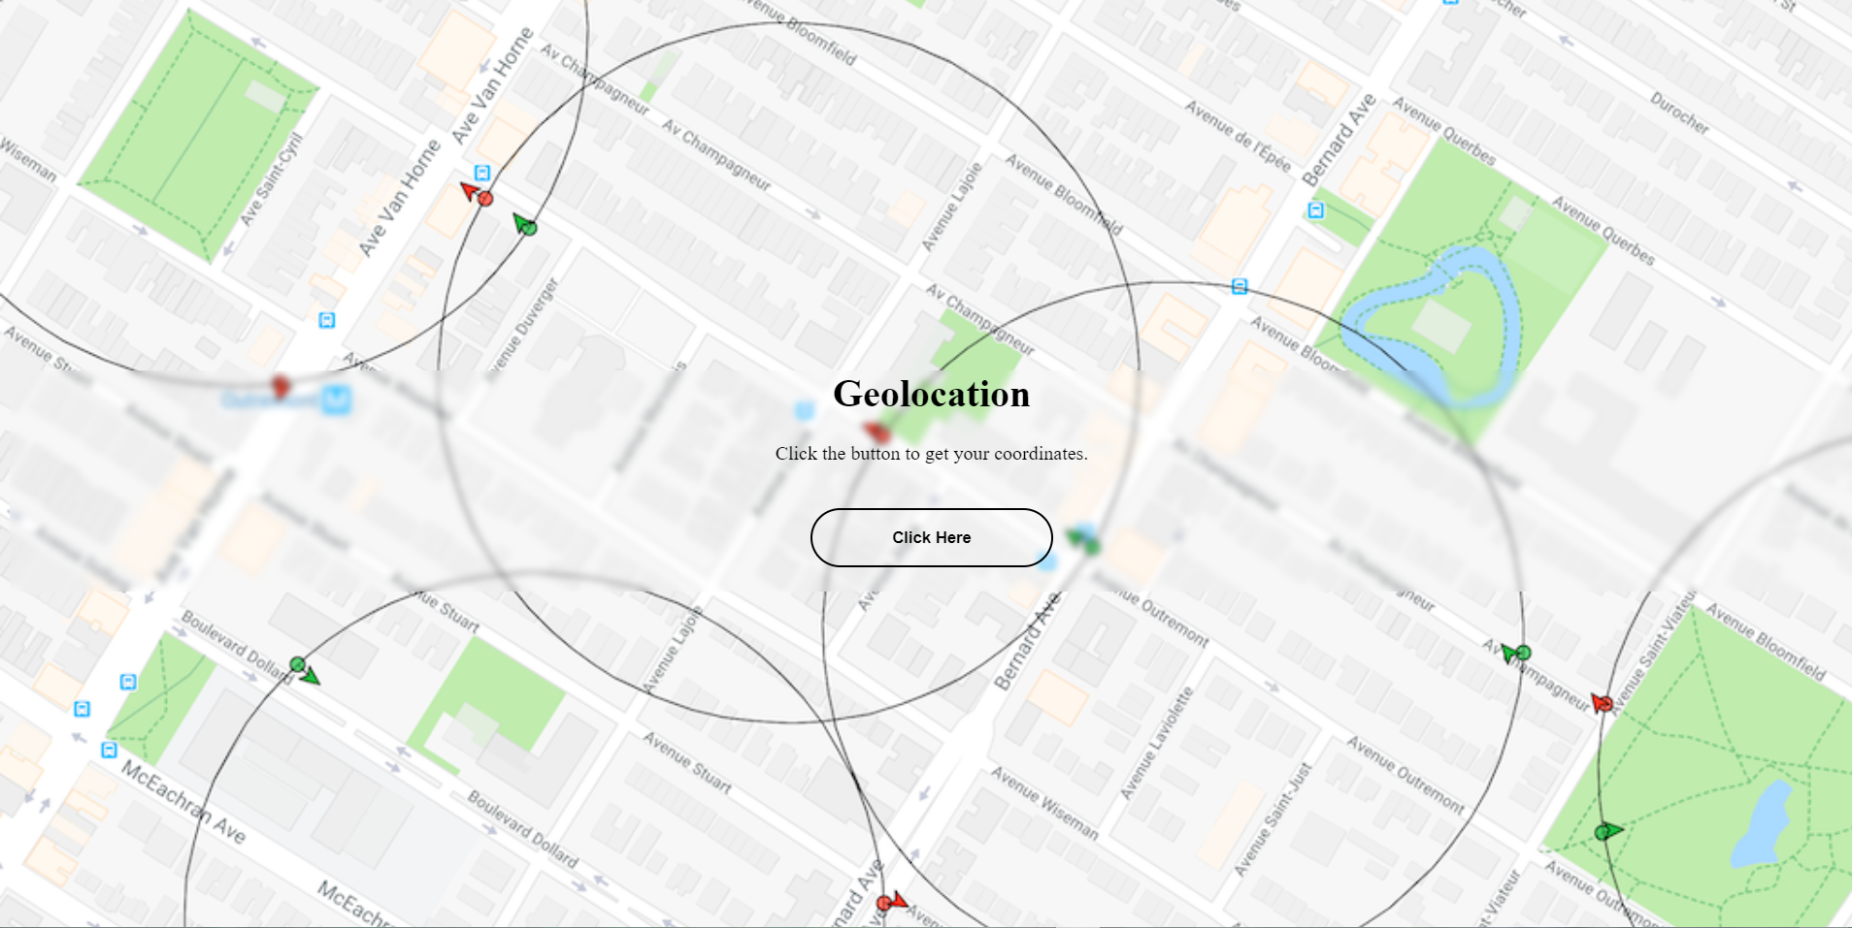

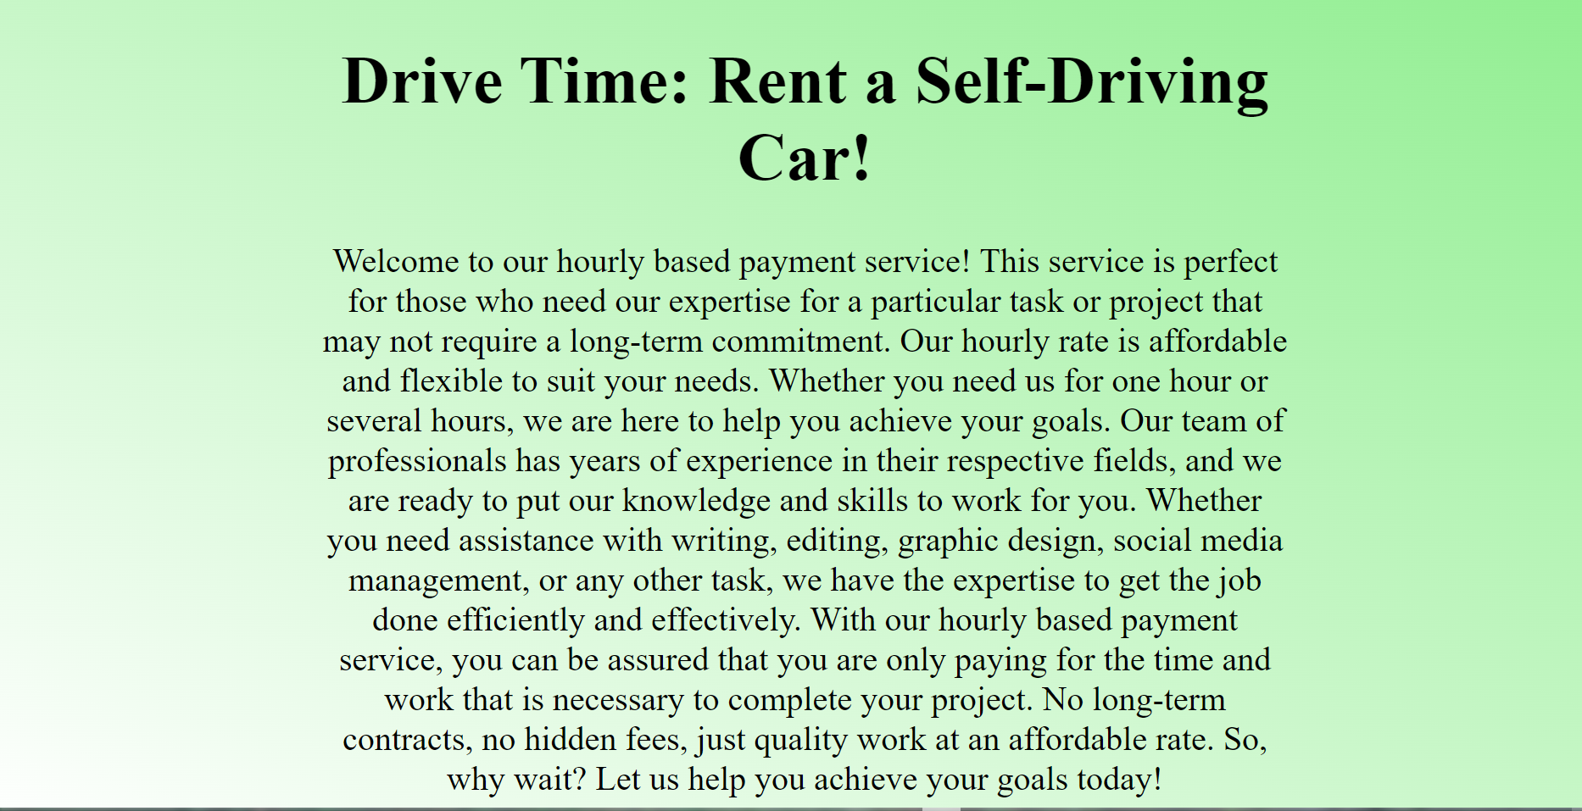

**Chapter 6**

**Frameworks Specification (Frontend/Backend)**

However, the code itself does not explicitly mention the specific frontend framework or library used. To determine the frontend framework, it would be helpful to identify any additional files or dependencies included in the project.

From the code snippet, I can observe the following:

1. HTML: The code includes HTML tags that structure the web page content and define its elements.

2. CSS: The code includes inline CSS styles and links to an external CSS file ("style.css"). CSS is responsible for styling the elements and controlling their appearance.

Based on the absence of any specific frontend framework-related code or dependencies, it seems that the web page has been developed using standard HTML, CSS, without relying on any particular frontend framework or library.

**Chapter 7**

**Conclusion & Future Enhancement**

**The web page, titled "Wheels4U," aims to promote a car rental service. The web page utilizes HTML, CSS, and JavaScript to create a visually appealing and user-friendly interface. It showcases the key features and benefits of the car rental service, such as self-driving options, affordable rates, and reliable rentals.**

**The web page incorporates elements like images, headings, paragraphs, and buttons to effectively communicate the information and entice users to explore more about the car rental service. The navigation menu enables users to access different sections of the website, including information about the company, available cars, rental details, and an API integration for obtaining coordinates.**

**Future Enhancements:**

**To further enhance the web page and improve the user experience, several future enhancements can be considered:**

**1. Responsive Design: Implementing a responsive design approach would ensure that the web page adapts and displays optimally across different devices and screen sizes, including smartphones and tablets.**

**2. Booking Functionality: Integrate a booking system that allows users to check car availability, select rental dates, and make reservations directly on the web page.**

**3. User Authentication: Implement a user authentication system to provide personalized experiences, such as saving preferences, managing bookings, and accessing exclusive offers.**

**4. Reviews and Testimonials: Include a section for user reviews and testimonials to build trust and credibility among potential customers.**

**5. Interactive Map: Incorporate an interactive map to display rental locations, nearby attractions, and driving directions for a seamless user experience.**

**6. Social Media Integration: Expand the presence on social media platforms by integrating social media buttons, allowing users to share their experiences and follow the car rental service's updates.**

**7. Integration with Payment Gateways: Enable secure online payments by integrating popular payment gateways to streamline the rental booking and payment process.**

**8. Multilingual Support: Incorporate multilingual support to cater to a broader audience and provide a localized experience.**

**By implementing these future enhancements, the web page can become more dynamic, engaging, and user-friendly, ultimately attracting and retaining more customers for the car rental service.**

**References**

Certainly! Here are some references that could be useful for a web project like the one described:

1. MDN Web Docs (https://developer.mozilla.org/): MDN Web Docs is a comprehensive resource for web developers. It provides detailed documentation and guides on HTML, CSS, and JavaScript, as well as information on various web APIs and technologies.

2. W3Schools (https://www.w3schools.com/): W3Schools is a popular online platform that offers tutorials, references, and examples for web development languages and technologies. It covers HTML, CSS, JavaScript, and various frameworks and libraries.

3. CSS-Tricks (https://css-tricks.com/): CSS-Tricks is a website dedicated to CSS tutorials, tips, and tricks. It provides in-depth articles, code snippets, and demos related to CSS and front-end web development.

4. JavaScript.info (https://javascript.info/): JavaScript.info is a comprehensive resource for learning JavaScript. It covers the language from basics to advanced concepts, and includes interactive examples and exercises.

5. Responsive Web Design Basics (https://developers.google.com/web/fundamentals/design-and-ux/responsive/): This guide by Google Developers provides an overview of responsive web design principles and best practices. It covers techniques for creating web pages that adapt and respond to different devices and screen sizes.

6. Official Documentation of Frontend Frameworks: If you have used a specific frontend framework or library, referring to its official documentation can provide detailed information on its features, usage, and best practices. Examples include React (https://reactjs.org/docs/), Angular (https://angular.io/docs), and Vue.js (https://vuejs.org/v2/guide/).

7. Online Forums and Communities: Participating in online forums and communities like Stack Overflow (https://stackoverflow.com/) or Reddit's webdev subreddit (https://www.reddit.com/r/webdev/) can provide valuable insights, tips, and solutions from experienced developers who have encountered similar challenges.

**Appendix**

**- `<html>`: Represents the root element of an HTML document.**

**- `<head>`: Contains meta-information about the HTML document, such as title, character encoding, and stylesheets.**

**- `<meta>`: Specifies meta-information about the HTML document, such as character encoding and viewport settings.**

**- `<title>`: Defines the title of the HTML document, which appears in the browser's title bar or tab.**

**- `<iframe>`: Represents an inline frame, used to embed another HTML document within the current document.**

**- `<link>`: Specifies external resources, such as stylesheets or icons, to be used by the HTML document.**

**- `<style>`: Contains CSS rules and styles to be applied to the HTML elements within the `<style>` block.**

**- `<body>`: Contains the content of the HTML document that will be displayed in the browser.**

**- `<script>`: Includes or references an external JavaScript file or contains inline JavaScript code.**

**- `<div>`: Defines a division or a container for grouping and styling HTML elements.**

**- `<h1>`, `<h2>`, `<h3>`: Heading tags used to define different levels of headings.**

**- `<p>`: Represents a paragraph of text.**

**- `<br>`: Inserts a line break or a single line break within a paragraph.**

**- `<img>`: Inserts an image into the HTML document.**

**- `<ul>`: Defines an unordered list.**

**- `<li>`: Represents a list item within an unordered or ordered list.**

**- `<a>`: Creates a hyperlink or anchor link to another web page or resource.**